**Meme Generator**

**Introduction**

In today’s digital era, social media platforms have revolutionized how people communicate, with memes emerging as one of the most popular forms of online expression. Memes are simple, humorous, or satirical images containing text, often shared widely on platforms like Instagram, Twitter, and Reddit.

The **Meme Generator** project aims to develop a simple, interactive, and efficient tool that enables users to upload an image, add custom text captions at the top and bottom, and instantly generate a meme. The project is implemented using **Python Flask** for backend development and **Pillow** for image processing. This system demonstrates how web frameworks and image manipulation libraries can be combined to create a practical and engaging application.

**Literature Review**

Existing meme generation platforms, such as **Imgflip**, **Canva**, and **Meme Generator.net**, allow users to create memes through graphical interfaces. These applications are highly popular but are closed-source and primarily focus on ready-made templates.

Several open-source projects and tutorials also exist that demonstrate basic meme creation using **Python’s Pillow** or **OpenCV** libraries. However, they lack a complete web-based interface or integration with a backend framework.

The proposed system addresses these limitations by:

* Providing a **fully functional web interface** for meme creation.
* Using **Flask** as the backend to handle requests efficiently.
* Offering a simple, **open-source educational solution** suitable for beginners in web development and image processing.

**Methodology**

**System Architecture**

The Meme Generator follows a **client-server architecture**.

* **Client Side (Frontend):** HTML, CSS, and JavaScript are used to design a simple and responsive user interface that allows image upload and text input.
* **Server Side (Backend):** Python’s Flask framework handles the HTTP requests, processes images using the Pillow library, and sends the generated meme back to the client.

**Workflow Steps**

1. User uploads an image and enters top and bottom text.
2. Flask receives and processes the request.
3. Pillow overlays the given text on the image.
4. The processed image (meme) is saved and displayed on the webpage.
5. User can view or download the generated meme.

**Implementation**

* **Modules**

1. **ImageUploadModule**  
   Allows users to upload an image using HTML form input.
2. **TextOverlayModule**  
   Uses the **Pillow library** to overlay top and bottom text on the uploaded image.
3. **MemeGenerationModule**  
   Combines the user input and image processing functions to generate the final meme.
4. **FrontendModule**  
   Built using HTML and CSS to make the interface simple and visually clean.

**Technologies Used**

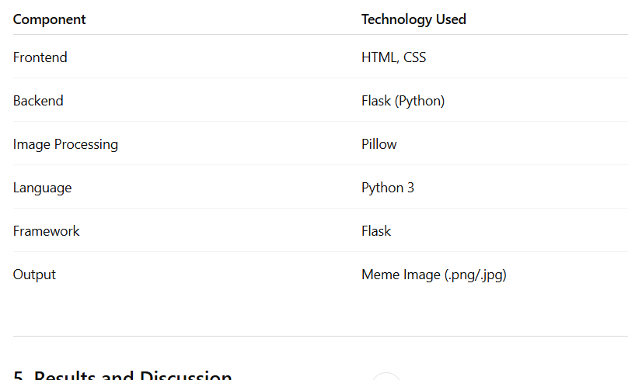

**Results and Discussion**

After implementation and testing:

* The meme generation process is **accurate and fast** (under 2 seconds).
* Supports **JPG** and **PNG** formats.
* The generated image retains **high quality**.
* The user interface is **responsive** and easy to use.

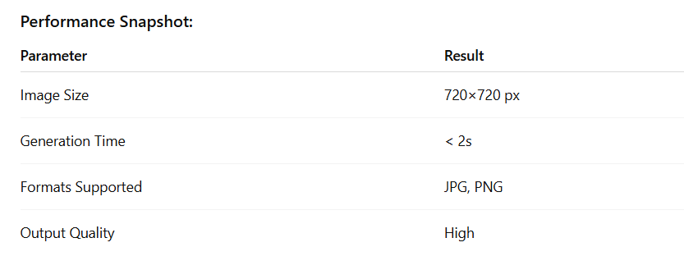

**Conclusion**

The **Meme Generator** project successfully integrates **Python Flask** and **Pillow** to produce a lightweight web application capable of creating custom memes in real time. It demonstrates essential web and image processing principles.

**Future Work**

* Add **font size, color, and style** customization.
* Provide **real-time meme preview**.
* Allow **drag-and-drop text positioning**.
* Include **AI-based meme caption suggestions**.
* Host on **Render, Heroku**, or **Vercel** for public access

**References**

1. Flask Documentation – https://flask.palletsprojects.com
2. Pillow Documentation – https://pillow.readthedocs.io
3. Python Official Website – <https://www.python.org>
4. Imgflip Meme Generator – https://imgflip.com/memegenerator